2.1 Using Models to Multiply Integers
Instructions
1. Start at 0
2. The first integer tells you what direction to face and how many sets to move.
3. The second integer tells you to walk forward or backwards and how many groups.
4. The answer is your location at the end.

Example $(-3)×(-2)$
Walk backwards groups of 2
Face the negative direction (left) and move 3 sets

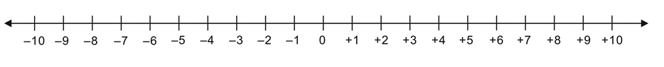

Practice
1. $(-3)×(+2)$

2. $(+3)×(-2)$

3. $(+3)×(+2)$

4. $(-9)×(-3)$

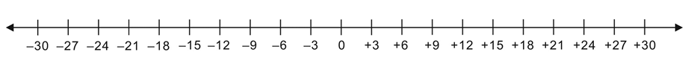

5. $(+8)×(-4)$

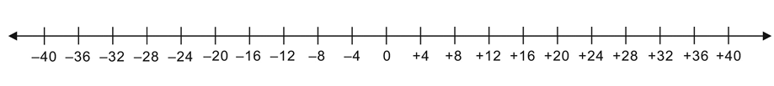

6. $(-7)×(+5)$

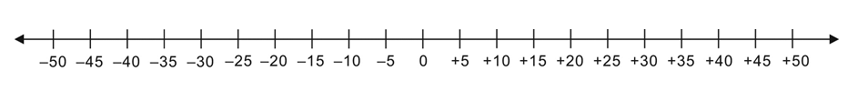

7. $(+10)×(+6)$

8. $(-10)×(-10)$

