3.1 What is a Rational Number?



A **Rational Number** is__________________________________________________________



____________________________________________________________________________



Example (1): Which rational numbers are equal?



$\frac{5}{7}$ $-\frac{5}{7}$ $\frac{5}{-7}$ $\frac{-5}{-7}$ $\frac{-5}{7}$

Example (2): Write the rational number represented by each letter on the number line, as a **decimal**.



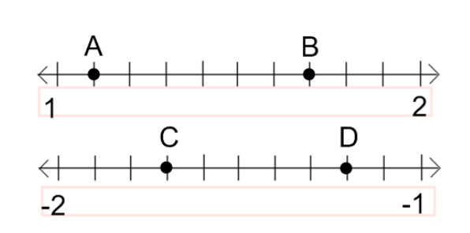



A =

B =

C =

D =

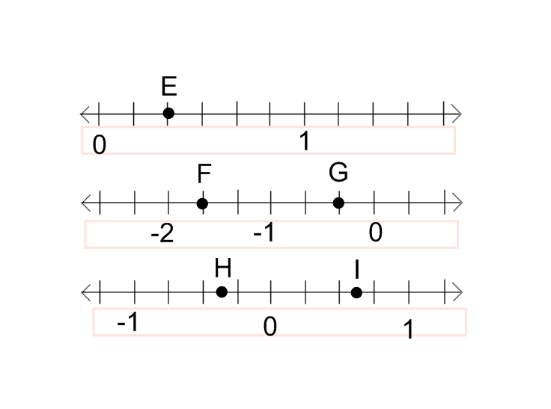



Example (3): Write the rational number represented by each letter on the number line, as a **fraction**.



E =

F =

G =

H =

I =



Example (3): Write three rational numbers between each pair of numbers.



1. 5.2 and 5.3 (b) -4.6 and -6.2 (c) $-\frac{3}{7}$ and $-\frac{7}{8}$ (d) $\frac{1}{3}$ and $\frac{2}{3}$



Example (4): Which rational number is greater?



(a) $\frac{5}{7}$ and $\frac{4}{5}$ (b) $-\frac{5}{9}$ and $-\frac{2}{3}$ (c) $-\frac{17}{20}$ and $-\frac{21}{25}$



Example (5): Show the set of numbers on a number line.

$-1.5, \frac{7}{8}, 1.3, \frac{5}{6}, -\frac{3}{10}, -\frac{7}{8}$