**3.4 Multiplying Rational Numbers**

* 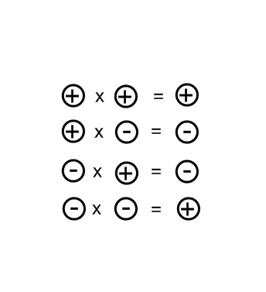To multiply fractions, multiply the numerator by the numerator, and, the denominator by the denominator. (**TOP** by **TOP** and **BOTTOM** by **BOTTOM**).
* Apply yug numberator by the numb integer rules.

Ex (1): $-\frac{4}{7}×\frac{5}{8}$ Ex (2): $-\frac{1}{2}∙-3$ Ex (3): ${\left(\frac{3}{4}\right)}^{2}$



* To multiply mixed numbers, change them to improper fractions first and then use the fraction and integer rules.

Ex (4): $-2\frac{4}{5}×-3\frac{1}{4}$ Ex (5): $-6\frac{4}{5}×-2\frac{1}{2}$

