4.3: Area of a Parallelogram
1. Calculate the area of each parallelogram.
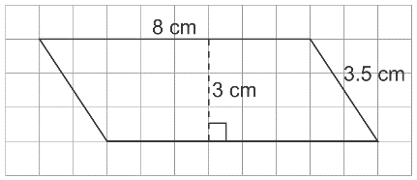
a)

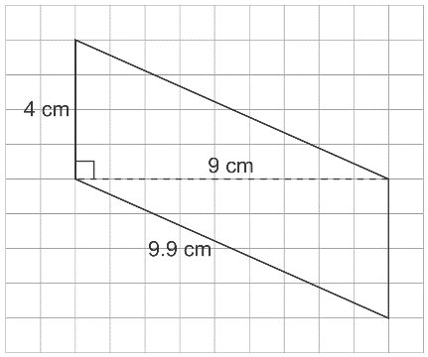

b)

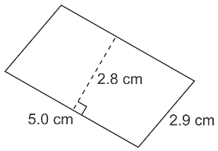
c)

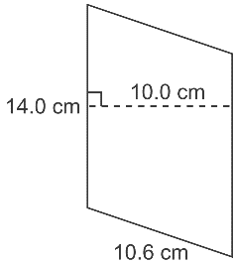
d)

2. The base of a parallelogram is 25 m. What is the height of the parallelogram for each area?
a) 100 m² b) 375 m² c) 225 m² d) 12.5 m²

3. Draw 3 different parallelograms with base 3 cm and height 1 cm.

4. Draw as many different parallelograms as you can with area 24 cm².

