4.7 Surface Area of a Right Cylinder – Worksheet

1. Calculate the surface area of each cylinder.
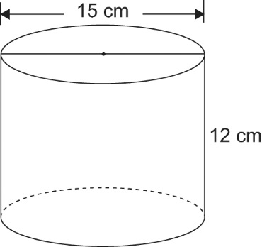
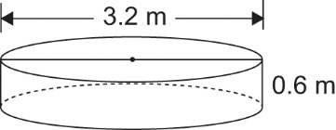
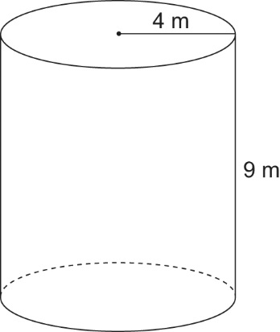
a) b) c)

2. Find the surface area of a cylinder with the following dimensions:
a) height 10 cm, radius 3 cm b) height 8 mm, diameter 12 mm

3. A cylindrical-shaped building block is to be painted. It has diameter 5.3 cm and height 12 cm.
Calculate the surface area to be painted.

4. A cylindrical candle has diameter 9 cm and height 12 cm.
It is placed in a cylindrical box.
There is a space of 0.5 cm between the candle and the box to allow for packing material.
a) What is the height of the cylindrical box?
b) What is the radius of the cylindrical box?
c) What is the surface area of the box?

