7.2 Misleading Graphs – Notes

Scale Not Starting at Zero or Uneven Scale
Here is a graph that has made a tiny difference look huge by using small scale units, and drawing the bars in 3D. Not starting at zero is the most common “trick” with graphs to try and show a large difference.
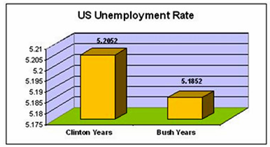
Using Bars of Different Widths or Changing Perspective
In this next graph, the bowling average difference between Emily and Diana is only 5, but is made to look much larger. The 3D perspective can also give the wrong impression
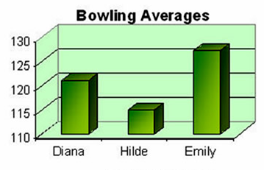

This next graph makes it look like there were twice as many freezing days in the USA in 2008 compared to 2007, when there were in fact only two extra freezing days in 2007.
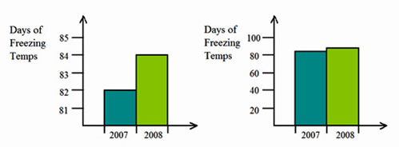
Both show exactly the dame data. However, the graph on the left makes the change appear to be much larger than it really is because the numbers on the vertical axis do not start at 0. Each vertical mark on the left graph represents 1 and each mark on the right represent 20.

This next graph makes the House Prices in 2006 look huge compared to 1975.
Also the next year after 1995 on the horizontal scale should in fact be 2005, and not 2006.
The scale does not start at zero, and makes the house price in 2006 look about seven times higher than 1975, when it is really about 2.5 times higher
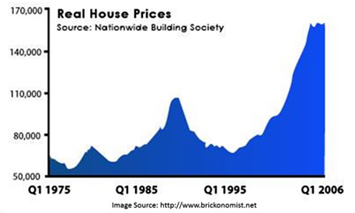
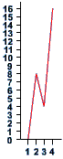
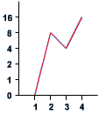
Although the vertical scale starts at 0 on both graphs to the left, it does not go up in even steps. This has the effect of distorting the graph, and making it look as though the biggest jump is between 1 and 2 rather than 3 and 4. Also, there are no labels on the axes. We have no idea what this graph represents!

Misleading Picture Graphs
In Picture Graphs, (also called “Pictographs”), all of the image icons used to represent the different items should be made the same size. By making these items different sizes, we can try and trick people who are looking at the Graph.
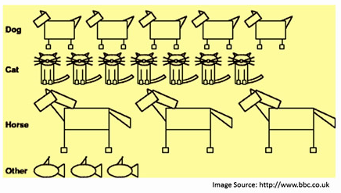
Also, on this Pictogram there isn't a category for those people who do not own a pet. The pictures are different sizes and it appears that more people own a horse than any other animal. An improvement would be to redraw the pictogram with each of the animals the same size and aligned with one another.
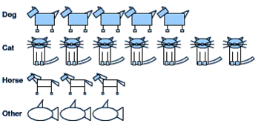
Oversized Volumes on Graphs
In these type of graphs, images are used to replace normal vertical bars, and some of the volumes or sizes of these images are made much bigger than they should be.
In this Picture Graph, the year 2000 picture is about 8 times bigger than the 1960 image. However when we check on the vertical scale, year 2000 is only 2.5 times bigger.
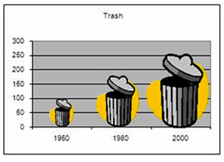
Here is another misleading graph, where the volume of the second image is about one and a half times bigger than it should really be.
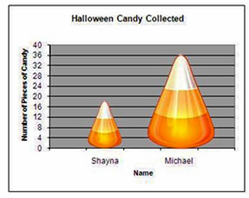

Incorrect Pie Charts
In these graphs, the pieces of pie sections are made the wrong size.
In the graph below, the right hand side pieces add up to 145 million, which is not equal to the 250 million piece on the left hand side.
Also the 10% piece has been made way too big.
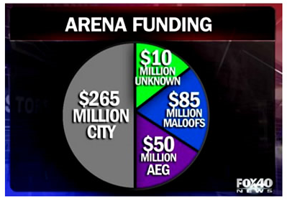
You may think that milk is the favourite drink by looking at the pie chart below. It is misleading to emphasize a single part of any graph.
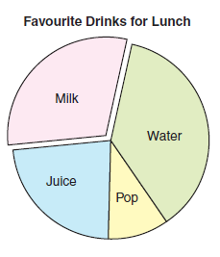
7.2 Misleading Graphs – Notes

The following are some ways in which graphs can be misrepresented:
• Starting the scale at a number other than zero
• Using bars of different widths (area)
• Absence of a scale
• Larger symbols used for a particular category on a pictograph
• No key given for pictograph symbol
• Sections of a pie graph pulled away from the other sectors to emphasize it

