Grade 7 Review – Units 1 – 4 (Up to 4.5)

This review is only a guide and does not include all types of questions that are possible on the exam. Students must also review their notes and examples done in class to ensure a complete review.
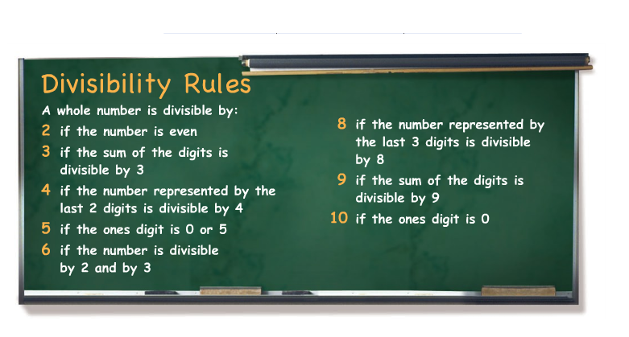
Unit 1 – Patterns and Relations

Note that a number cannot be divided by zero. This is because a number cannot be separated into groups of zeros. A number divided by zero is said to be undefined.

Venn Diagrams
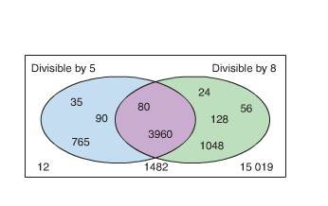
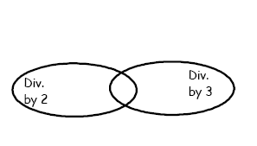
A venn diagram shows if a number is divisible by other numbers. If a number is placed in the appropriate circle, then that number is divisible by the number represented by that circle.

Examples:

If a number is placed in an overlapping region, the number is divisible by two or more numbers.

If a number is placed outside the circles, it is not divisible by any of the numbers represented by the circles.

Algebraic Expressions

A variable is a letter, such as n, that represents a quantity that can vary.

An Algebraic Expression is a mathematical expression that contains a variable or a combination of operations (+,-,x,) involving numbers and variables.

An example of an algebraic expression is 2x + 4

- In this expression, x is the variable, 2 is the numerical coefficient, and 4 is the constant term

Examples:

1) Evaluate the expression by replacing z with 7: 3+ 5z

2) A person earns $4 for each hour he spends baby-sitting.

a) Find the money earned for 5 hours of work

b) Write an algebraic expression you could use to find the money earned in t hours.
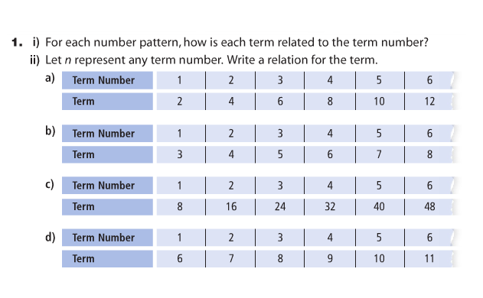
Patterns

Write an algebraic expression when given a term number and a term, or a sequence of numbers

Patterns and Relationships in Tables

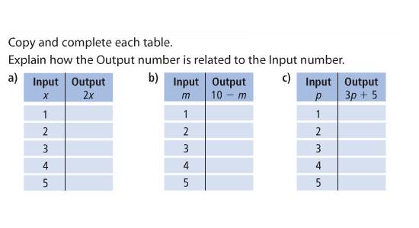
An input/output machine represents a relation

Given input and output expressions, find the output

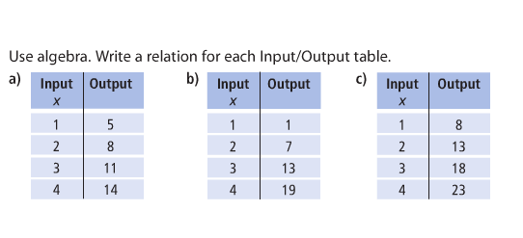
Given input and output values, construct an output expression

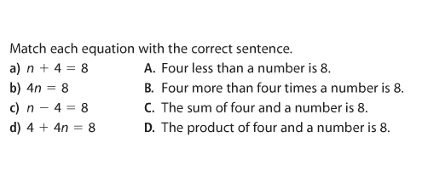
Reading and Writing Equations
Represent algebraic expressions with sentences and vice-versa

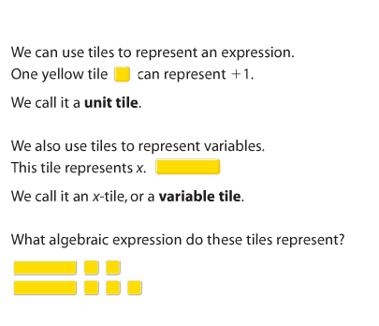
Solving Equations Using Algebra Tiles

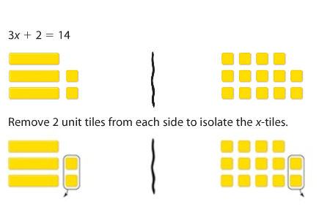
2x+5

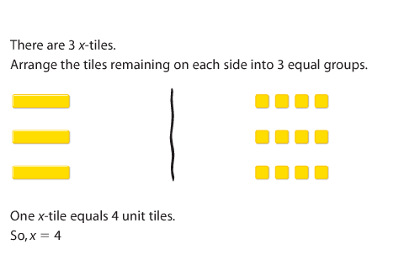

Representing Integers

An example of a negative integer is -1
An example of a positive integer is +1

Yellow and Red ( or White and Black) tiles can be used to represent integers

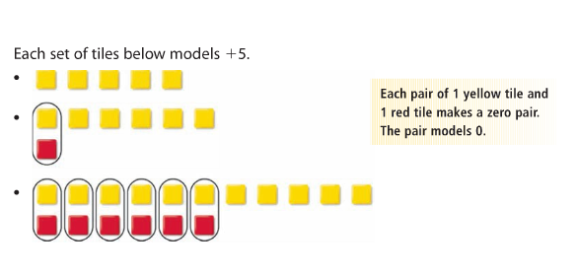
Yellow or white represent +1
Red or Black represent -1

Adding Integers

Adding two or more negative integers will always result in a negative integer

Adding two or more positive integers will always results in a positive integer

Adding a positive and negative integer could result in a positive OR negative integer

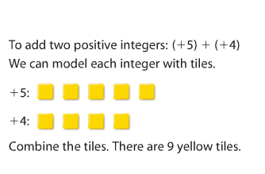

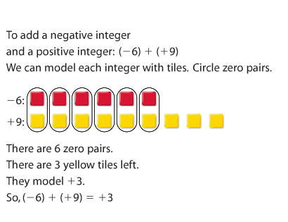

Adding Using a Number Line

Start by representing the first number on the number line (starting from 0). Then, starting from the endpoint of the first number, represent the next.

Example:

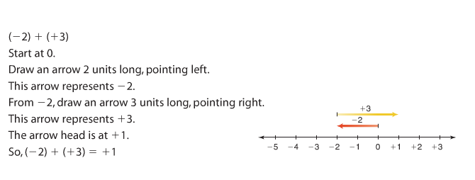

Subtracting Integers

Represent the first integer with the appropriate color. Then subtract the next integer. If you are subtracting the opposite integer, you must add zero pairs until you can subtract.

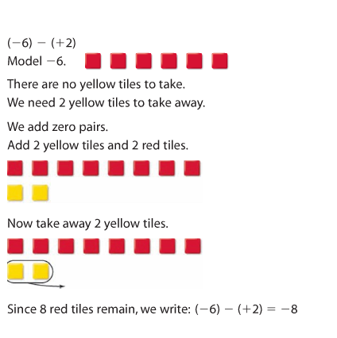
Example:

Subtracting Using a Number Line

Start by representing the first number on the number line (starting from 0). Then, starting from the endpoint of the first number, represent the next by adding the opposite.

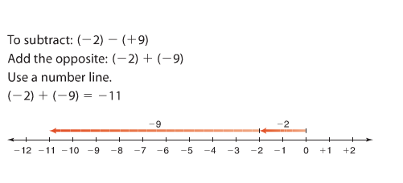
Example:

Fractions to Decimals

A fraction represents division. For example, means 1 divided by 10

Fractions can also be represented in decimal form.

A repeating decimal is a decimal that goes on forever

A terminating decimal is a decimal that ends.

The top number of a fraction is the numerator

The bottom number of a fraction is the denominator

When converting a fraction to a decimal, we try to write an equivalent fraction with the denominator as 10, 100 or 1000.

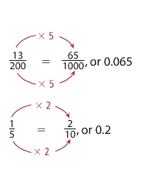
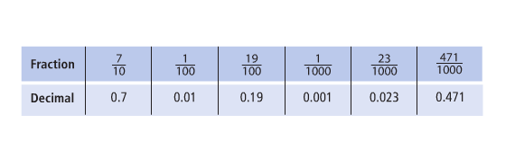

Calculators only have a certain number of spaces for numbers to appear, so if a number is too big, the calculator estimates the last digit.

Comparing and Ordering Fractions

If the numbers are all decimals, we can use place value to determine the order of the decimals.

If the numbers are all fractions, we can convert them to decimals or compare them using like numerators or denominators.

If the fractions have the same numerator, the fraction with the lowest denominator is the larger number.

If fractions have the same denominator, the fraction with the highest numerator is the larger number.

Benchmarks can also be used:

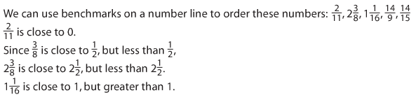

Adding and Subtracting Decimals
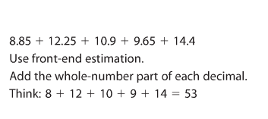
We can use front end estimation to estimate the result of an addition or subtraction operation.

When adding or subtracting decimals, the decimals and place values must line-up appropriately. You may need to add zeros to the end of a number for this to happen.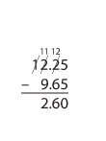

Multiplying Decimals

Using base-10 blocks
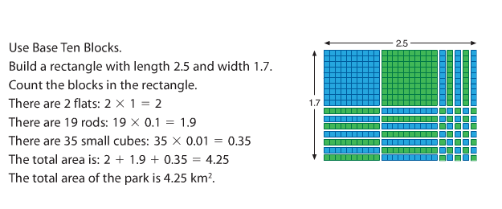
The decimal places do not need to line up for multiplication. Use front end estimation first, and then use the front-end estimation to place the decimal point.
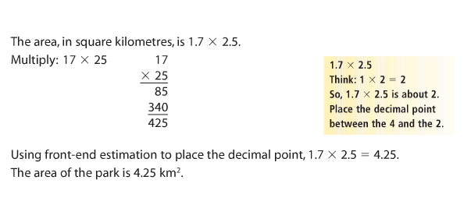

Dividing Decimals

Using base 10 blocks
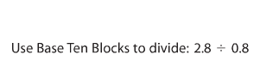
(1)Count 0.8 from top to bottom and
(2)Fill in a rectangle until you have a rectangle with 280 one-blocks in it
(3)Count the number of blocks on the top for the answer (ten blocks represents 1 whole)

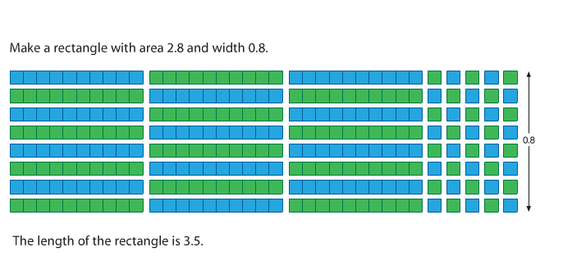

Dividing Decimals Without Base-10 Blocks

First use front end estimation

Divide and place the decimal according to your estimation

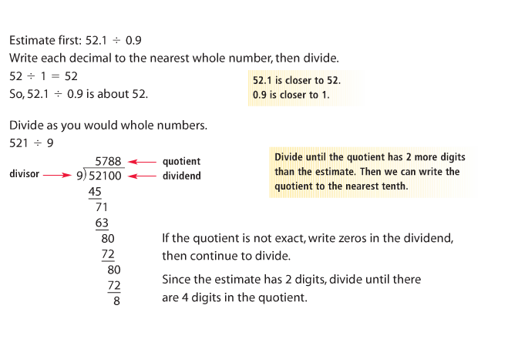

The answer is 57.88

Order of Operations - BEDMAS

(1) Brackets must be completed first
(2) Exponents next (we do not deal with these yet)
(3) Division OR Multiplication in the order they appear (left to right)
(4) Addition OR Subtraction in the order they appear (left to right)

Example:
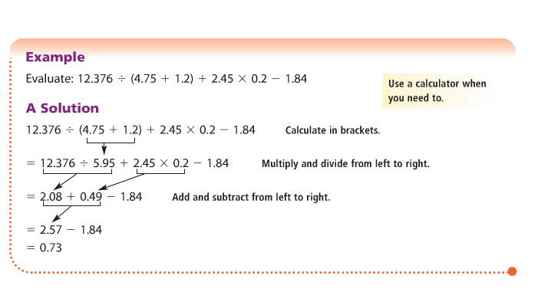
Relating Decimals, Fractions and Percents
Percents are numbers out of 100. For example 90% is the same as . It is also the same as 0.90

You can change fractions into percents by making an equivalent fraction so that the denominator is 100. The numerator is now the percentage.

To change a decimal into a percent, multiply it by 100

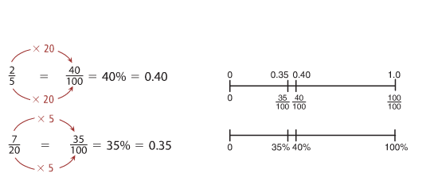

Circles and Area

Circles

The radius of a circle is any line drawn from the center point of the circle to the outside

The diameter of a circle is the longest line possible inside of a circle. It is drawn through the center point and extends to both ends of a circle

The diameter is 2 times the length of the radius

The circumference of a circle is the length of the edge of a circle
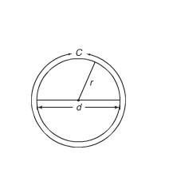
The circumference is $π$ times the diameter or $π$ times twice the radius

C=$π$d

C=2$π$r

The area of a circle is $π$x r x r or A=$π$ x r x r

Parallelograms

A parallelogram is a shape that has opposite sides parallel. If both opposite sides continued in the same direction, they would never meet.
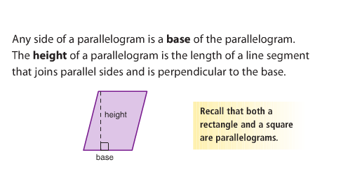
The area of a parallelogram is base x height

A=b x h

Area of a triangle

Since triangles are half of a parallelogram, the area of a parallelogram is base x height divided by 2.

A=
