Constructed Response
11. Given the equation: $y-3x+6=0$ [5 marks]
- Complete a table of values for the given values of $x$ (Show steps for one $y$-value calculation).
$$x$$ | $$y$$
-2
0
2
3
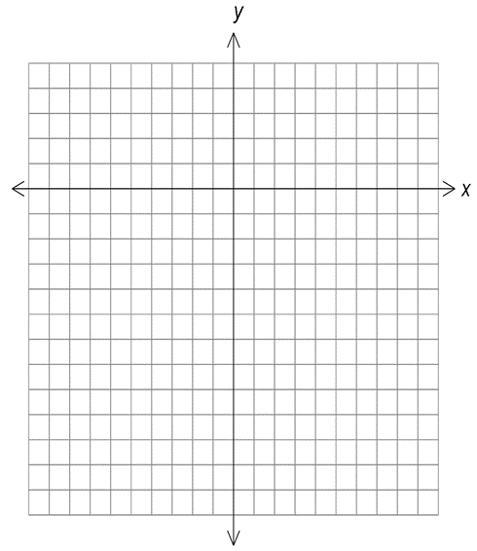
- Graph the equation

12. 13. Graph $2x-5=3$ [2 marks]
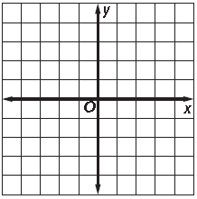

13. Matches are used to make a pattern of houses. Assume that the pattern continue as shown.

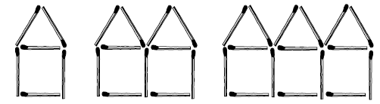

- Write an equation that shows the relationship between the number of matches $(m)$ and the number of houses$(h)$. [1 mark]

- Use your equation to determine how many houses can be built with 41 matches.
[1 marks]

C) Is the relation linear or nonlinear? Explain how you know. [1 mark]

D) Is the relation continuous or discrete? Explain how you know. [1 mark]

E) If you build 15 houses how many matches will you need? [1 mark]

F) When you answered part E) did you interpolate or extrapolate? Explain how you know. [1 mark]

15. Match Graphs A, B and C to the correct equation. Show all workings. [4 marks]
(i) $y = 2x – 4$ (ii) $2y+x=4$ (iii) $x=2y+4$
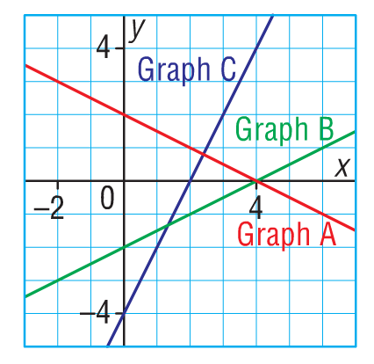

12. This graph represents Rachel’s savings account over the period of several weeks.
A) Estimate the amount of money Rachel has saved by week 18? Is this interpolation or extrapolation? Explain.
[2 marks]

B) Estimate the amount of money she will have saved by week 35? Is this interpolation or extrapolation? Explain. [2 marks]

C) Predict how long it will take her to save $3500. What assumptions are you making? [2 marks]

13. Sally walks toward a motion sensor while conducting a science experiment. She is 10 meters from the sensor when she starts and she walks 2 meters closer per second.
A) Complete the table of values. [2 marks]
Time (s) | 0 | 1 | 2 | 3 | 4
Distance from sensor(m)

B) Graph the information from the above table. [2 marks]
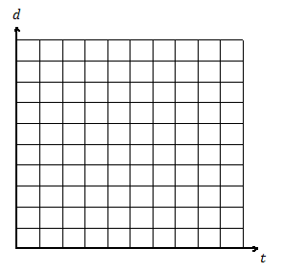

C) Determine the equation, where d represents distance in meters and t represents time in seconds. [2 marks]

D) Explain why you did or did not connect the points in the graph for question 8B) above. [1 marks]

