Surface Area – Review

1. A cylindrical hot water tank has a diameter of 4.4 m and height 2.1 m.
A) What is the surface area of the cylinder?

B) How many cans of paint are needed to paint the hot water tank, if one can of paint covers 25 m²?

2. What is the area of the curved surface?
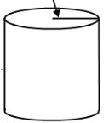
8 cm
3 cm

3. What is the surface area for the rectangular prism?
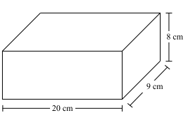

4. A rectangular prism building is 50 m by 43 m by 65 m. The building owner wants to paint the 4 walls. What is the surface area to be painted?

5. What is the surface area of the triangular prism?
